NST21022 - Practical for Network Switching and Routing
Department of Information and Communication Technology
Faculty of Technology
Lab sheet :06
Reg. Number: SEU/IS/20/ICT/084
Academic Year :2020/2021
Practical No :06

Title: Internet Protocol version 4 (IPv4) Subnet
Aim:
• IP addressing scheme.
• Getting familiar with IPv4 subnets
• Configure devices with IPv4 after subnetting.
Task:
• Design an IP scheme.
• Subnet the IPv4 address
• Assign IP address to Network devices and verify connectivity

Use “NST21022 Labsheet 06.pka” file Activities

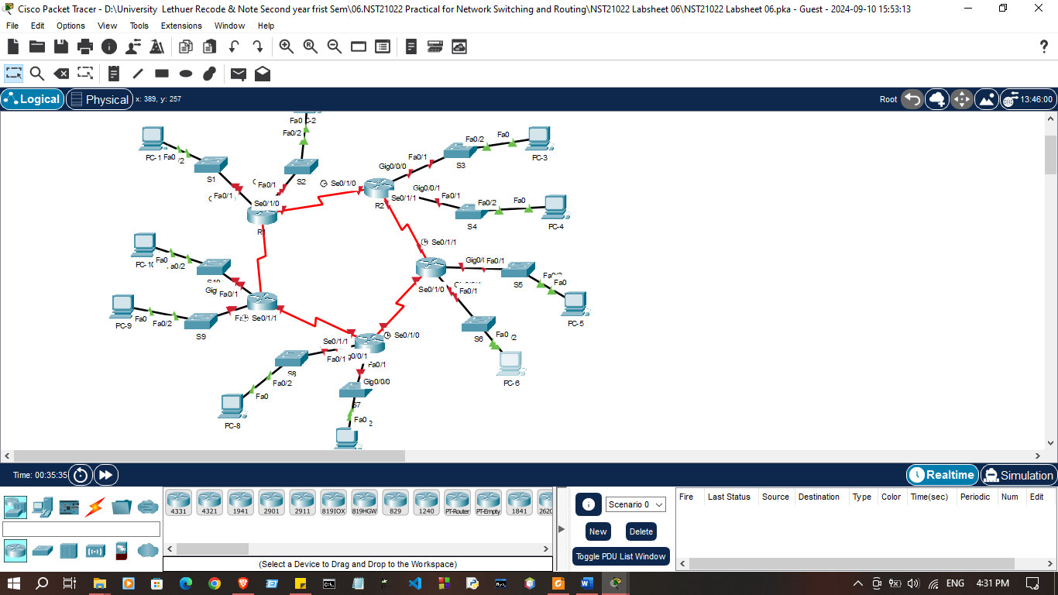

Exercise 01: Subnet the 172.16.1.0/24 network into the appropriate number of subnets.

- Based on the topology, how many subnets were needed?
- 15
- How many bits must be borrowed to support the number of subnets in the topology table?
- 4
- How many subnets does this create?
- 16
Exercise 02: Fill the subnet table
 | Network Address | First Usable Host Address | Last Usable Host Address | Broadcast Address
  Subnet Number
1 | 172.16.1.0 | 172.16.1.1 | 172.16.1.15 | 172.16.1.15
2 | 172.16.1.16 | 172.16.1.17 | 172.16.1.30 | 172.16.1.31
3 | 172.16.1.32 | 172.16.1.33 | 172.16.1.46 | 172.16.1.47
4 | 172.16.1.48 | 172.16.1.49 | 172.16.1.62 | 172.16.1.63
5 | 172.16.1.64 | 172.16.1.65 | 172.16.1.78 | 172.16.1.79
6 | 172.16.1.80 | 172.16.1.81 | 172.16.1.94 | 172.16.1.95
7 | 172.16.1.96 | 172.16.1.97 | 172.16.1.110 | 172.16.1.111
8 | 172.16.1.112 | 172.16.1.113 | 172.16.1.126 | 172.16.1.127
9 | 172.16.1.128 | 172.16.1.129 | 172.16.1.142 | 172.16.1.143
10 | 172.16.1.144 | 172.16.1.145 | 172.16.1.158 | 172.16.1.159
11 | 172.16.1.160 | 172.16.1.161 | 172.16.1.174 | 172.16.1.175
12 | 172.16.1.176 | 172.16.1.177 | 172.16.1.190 | 172.16.1.191
13 | 172.16.1.192 | 172.16.1.193 | 172.16.1.206 | 172.16.1.207
14 | 172.16.1.208 | 172.16.1.209 | 172.16.1.222 | 172.16.1.223
15 | 172.16.1.224 | 172.16.1.225 | 172.16.1.238 | 172.16.1.239
16 | 172.16.1.240 | 172.16.1.241 | 172.16.1.254 | 172.16.1.255

Exercise 03: Configure IP address according to following criteria.
1. Assign the subnets to the network shown in the topology.

- Assign Subnet 1 to the LAN connected to the GigabitEthernet 0/0/0 interface of R1:

Router>enable
Router#configure terminal
Enter configuration commands, one per line. End with CNTL/Z.
Router(config)#
Router(config)#
Router(config)#interface g0/0/0
Router(config-if)#ip address 172.16.1.1 255.255.255.240
Router(config-if)#no shutdown

Router(config-if)#
%LINK-5-CHANGED: Interface GigabitEthernet0/0/0, changed state to up

%LINEPROTO-5-UPDOWN: Line protocol on Interface GigabitEthernet0/0/0, changed state to up

Router(config-if)#

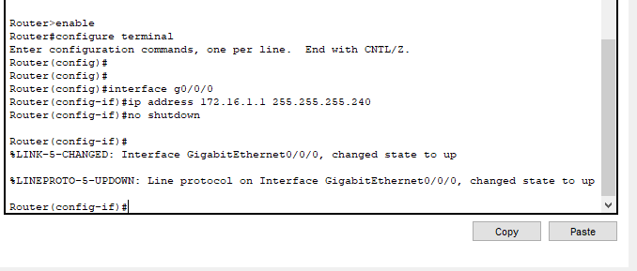

- Assign Subnet 2 to the LAN connected to the GigabitEthernet 0/0/1 interface of R1:

Router(config-if)#interface g0/0/1
Router(config-if)#ip address 172.16.1.17 255.255.255.240
Router(config-if)#no shutdown

Router(config-if)#
%LINK-5-CHANGED: Interface GigabitEthernet0/0/1, changed state to up

%LINEPROTO-5-UPDOWN: Line protocol on Interface GigabitEthernet0/0/1, changed state to up

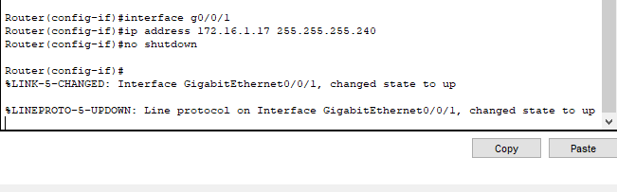

- Assign Subnet 3 to the LAN connected to the GigabitEthernet 0/0/0 interface of R2:

Router>enable
Router#configure terminal
Enter configuration commands, one per line. End with CNTL/Z.
Router(config)#
Router(config)#
Router(config)#interface g0/0/0
Router(config-if)#ip address 172.16.1.33 255.255.255.240
Router(config-if)#no shutdown

Router(config-if)#
%LINK-5-CHANGED: Interface GigabitEthernet0/0/0, changed state to up

%LINEPROTO-5-UPDOWN: Line protocol on Interface GigabitEthernet0/0/0, changed state to up

Router(config-if)#
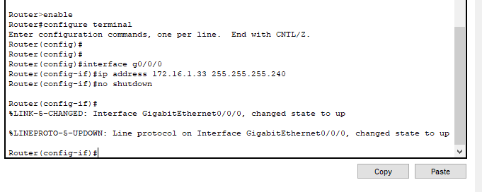

d. Assign Subnet 4 to the LAN connected to the GigabitEthernet 0/0/1 interface of R2:

Router(config-if)#interface g0/0/1
Router(config-if)#ip address 172.16.1.49 255.255.255.240
Router(config-if)#no shutdown

Router(config-if)#
%LINK-5-CHANGED: Interface GigabitEthernet0/0/1, changed state to up

%LINEPROTO-5-UPDOWN: Line protocol on Interface GigabitEthernet0/0/1, changed state to up

Router(config-if)#

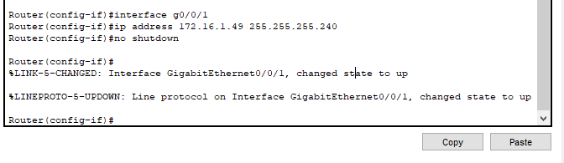

- Assign Subnet 5 to the LAN connected to the GigabitEthernet 0/0/0 interface of R3:

Router>
Router>enable
Router#configure terminal
Enter configuration commands, one per line. End with CNTL/Z.
Router(config)#
Router(config)#
Router(config)#interface g0/0/0
Router(config-if)#ip address 172.16.1.65 255.255.255.240
Router(config-if)#no shutdown

Router(config-if)#
%LINK-5-CHANGED: Interface GigabitEthernet0/0/0, changed state to up

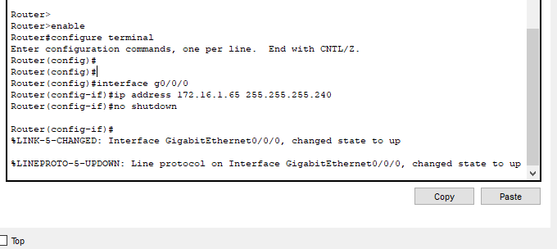
%LINEPROTO-5-UPDOWN: Line protocol on Interface GigabitEthernet0/0/0, changed state to up

- Assign Subnet 6 to the LAN connected to the GigabitEthernet 0/0/1 interface of R3:

Router(config-if)#interface g0/0/1
Router(config-if)#ip address 172.16.1.81 255.255.255.240
Router(config-if)#no shutdown

Router(config-if)#
%LINK-5-CHANGED: Interface GigabitEthernet0/0/1, changed state to up

%LINEPROTO-5-UPDOWN: Line protocol on Interface GigabitEthernet0/0/1, changed state to up

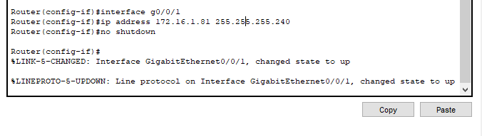

- Assign Subnet 7 to the LAN connected to the GigabitEthernet 0/0/0 interface of R4:

Router>enable
Router#configure terminal
Enter configuration commands, one per line. End with CNTL/Z.
Router(config)#
Router(config)#
Router(config)#interface g0/0/0
Router(config-if)#ip address 172.16.1.97 255.255.255.240
Router(config-if)#no shutdown

Router(config-if)#
%LINK-5-CHANGED: Interface GigabitEthernet0/0/0, changed state to up

%LINEPROTO-5-UPDOWN: Line protocol on Interface GigabitEthernet0/0/0, changed state to up

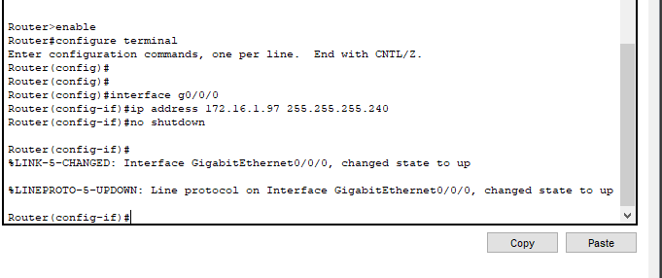

- Assign Subnet 8 to the LAN connected to the GigabitEthernet 0/0/1 interface of R4:

Router(config-if)#interface g0/0/1
Router(config-if)#ip address 172.16.1.113 255.255.255.240
Router(config-if)#no shutdown

Router(config-if)#
%LINK-5-CHANGED: Interface GigabitEthernet0/0/1, changed state to up

%LINEPROTO-5-UPDOWN: Line protocol on Interface GigabitEthernet0/0/1, changed state to up

Router(config-if)#

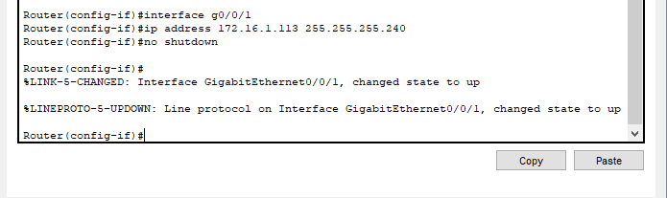

- Assign Subnet 9 to the LAN connected to the GigabitEthernet 0/0/0 interface of R5:

Router>enable
Router#configure terminal
Enter configuration commands, one per line. End with CNTL/Z.
Router(config)#
Router(config)#
Router(config)#interface g0/0/0
Router(config-if)#ip address 172.16.1.129 255.255.255.240
Router(config-if)#no shutdown

Router(config-if)#
%LINK-5-CHANGED: Interface GigabitEthernet0/0/0, changed state to up

%LINEPROTO-5-UPDOWN: Line protocol on Interface GigabitEthernet0/0/0, changed state to up

Router(config-if)#
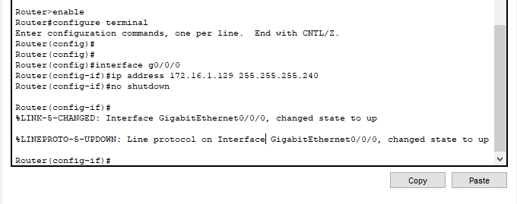

- Assign Subnet 10 to the LAN connected to the GigabitEthernet 0/0/1 interface of R5:

Router(config-if)#interface g0/0/1
Router(config-if)#ip address 172.16.1.145 255.255.255.240
Router(config-if)#no shutdown

Router(config-if)#
%LINK-5-CHANGED: Interface GigabitEthernet0/0/1, changed state to up

%LINEPROTO-5-UPDOWN: Line protocol on Interface GigabitEthernet0/0/1, changed state to up

Router(config-if)#

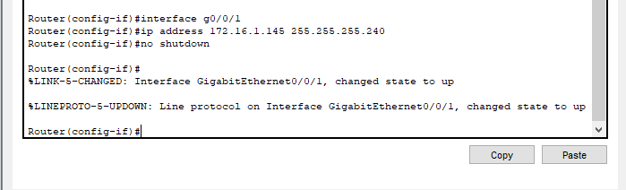
.

- Assign Subnet 11 to the WAN ling between R1 to R2:

Router>enable
Router#configure terminal
Enter configuration commands, one per line. End with CNTL/Z.
Router(config)#interface s0/1/0
Router(config-if)#ip address 172.16.1.161 255.255.255.240
Router(config-if)#no shutdown

%LINK-5-CHANGED: Interface Serial0/1/0, changed state to down
Router(config-if)#

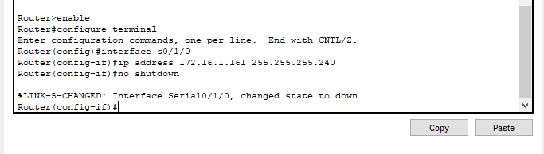

Router>enable
Router#configure terminal
Enter configuration commands, one per line. End with CNTL/Z.
Router(config)#
Router(config)#interface s0/1/0
Router(config-if)#ip address 172.16.1.174 255.255.255.240
Router(config-if)#no shutdown

Router(config-if)#
%LINK-5-CHANGED: Interface Serial0/1/0, changed state to up

Router(config-if)#

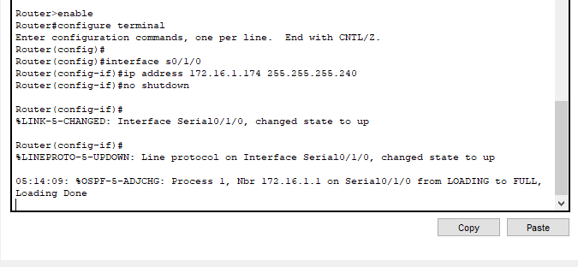

- Assign Subnet 12 to the WAN ling between R2 to R3:

Router(config-if)#interface s0/1/1
Router(config-if)#ip address 172.16.1.177 255.255.255.240
Router(config-if)#no shutdown

%LINK-5-CHANGED: Interface Serial0/1/1, changed state to down
Router(config-if)#
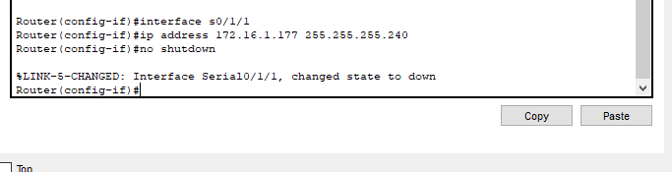

%LINK-5-CHANGED: Interface Serial0/1/0, changed state to down
Router(config-if)#interface s0/1/1
Router(config-if)#ip address 172.16.1.190 255.255.255.240
Router(config-if)#no shutdown

Router(config-if)#
%LINK-5-CHANGED: Interface Serial0/1/1, changed state to up

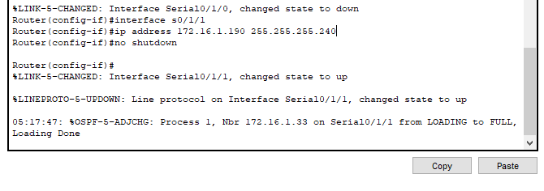

- Assign Subnet 13 to the WAN ling between R3 to R4:

Router>enable
Router#configure terminal
Enter configuration commands, one per line. End with CNTL/Z.
Router(config)#interface s0/1/0
Router(config-if)#ip address 172.16.1.193 255.255.255.240
Router(config-if)#no shutdown

%LINK-5-CHANGED: Interface Serial0/1/0, changed state to down
Router(config-if)#
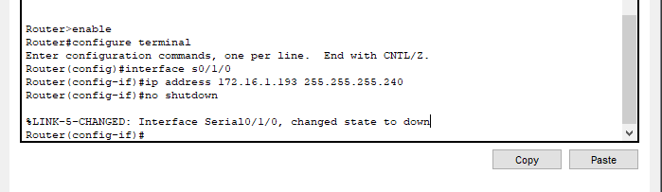
Router(config-if)#interface s0/1/0
Router(config-if)#ip address 172.16.1.206 255.255.255.240
Router(config-if)#no shutdown
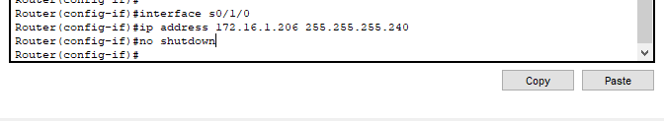
Router(config-if)#

- Assign Subnet 14 to the WAN ling between R4 to R5:

Router(config)#interface s0/1/1
Router(config-if)#ip address 172.16.1.209 255.255.255.240
Router(config-if)#no shutdown
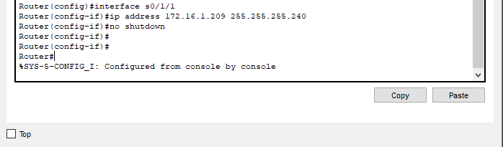
Router(config-if)#

Router(config)#interface s0/1/1
Router(config-if)#ip address 172.16.1.222 255.255.255.240
Router(config-if)#no shutdown

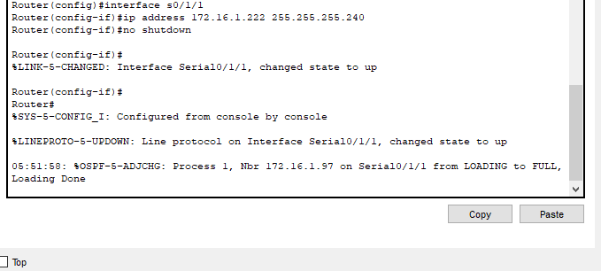

- Assign Subnet 15 to the WAN ling between R5 to R1:

Router(config)#
Router(config)#interface s0/1/1
Router(config-if)#ip address 172.16.1.222 255.255.255.240
Router(config-if)#no shutdown
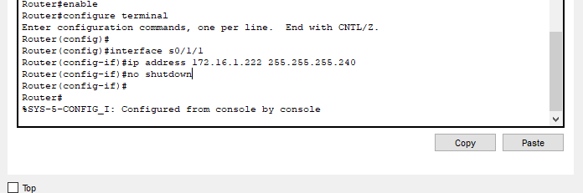
Router(config-if)#

Router(config)#
Router(config)#interface s0/1/1
Router(config-if)#ip address 172.16.1.238 255.255.255.240
Router(config-if)#no shutdown

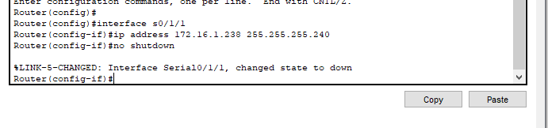
2. Fill the addressing table using following guidelines:

a. Assign the first usable IP addresses in each subnet to all LAN link in all routers.
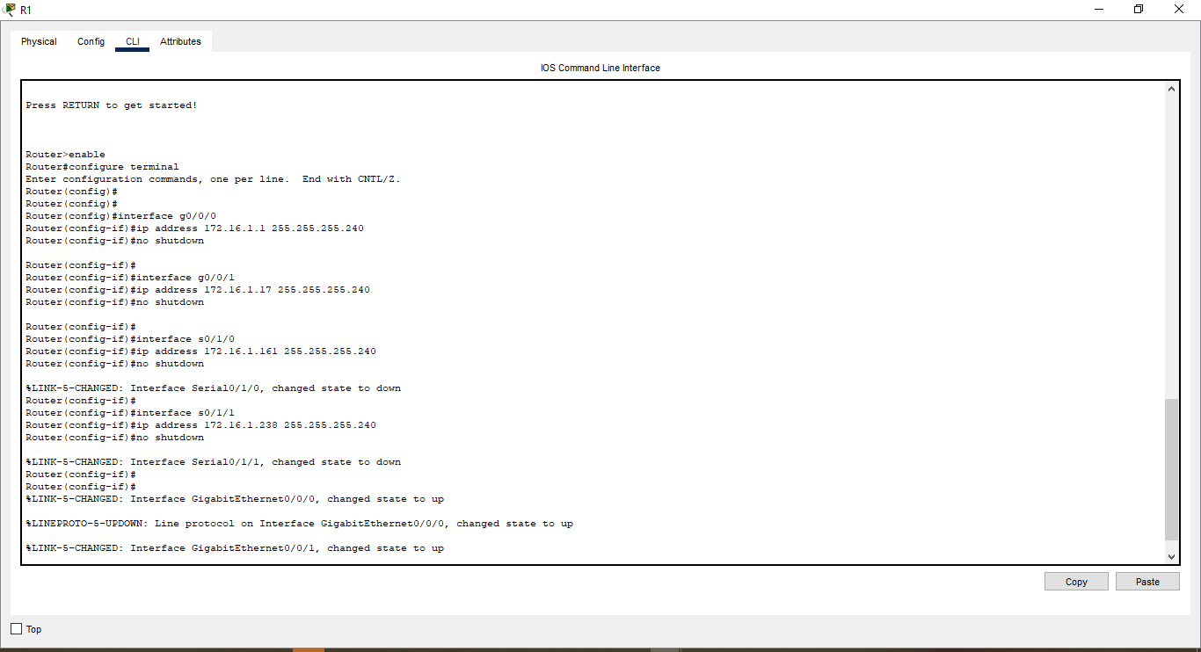
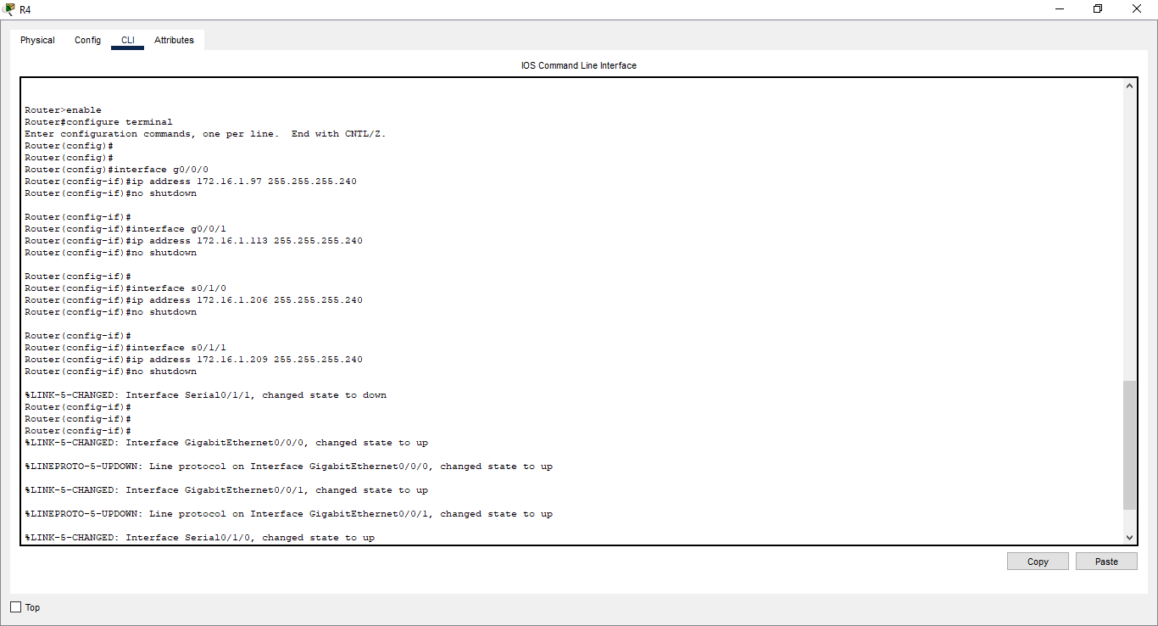
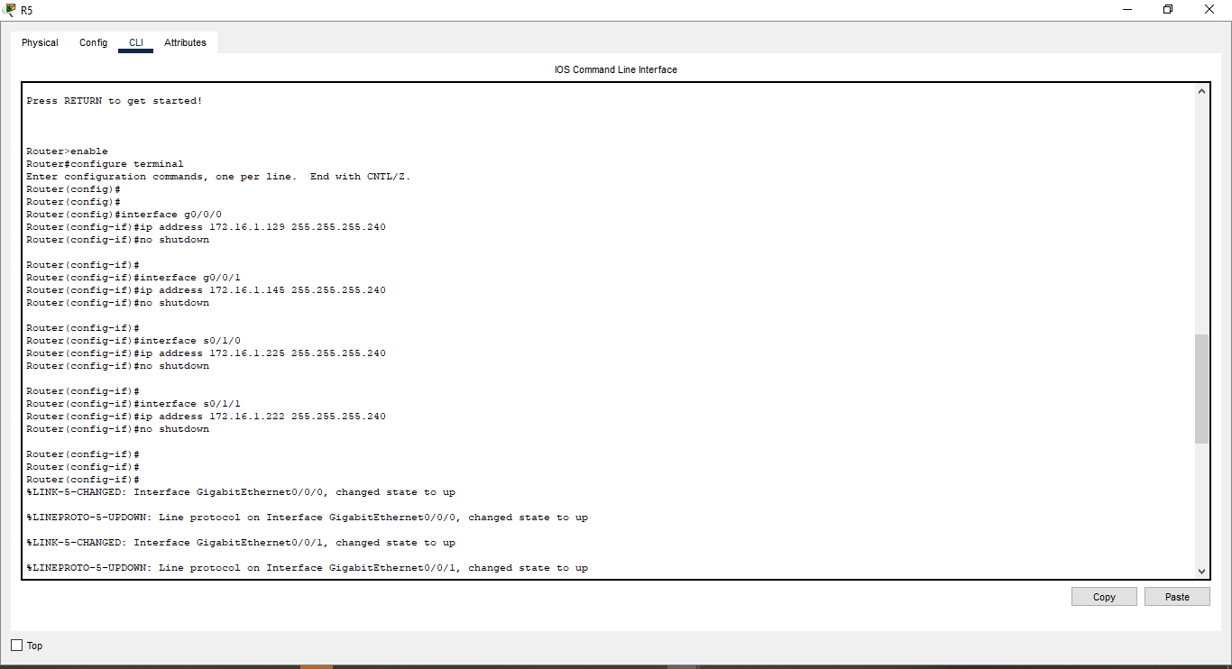

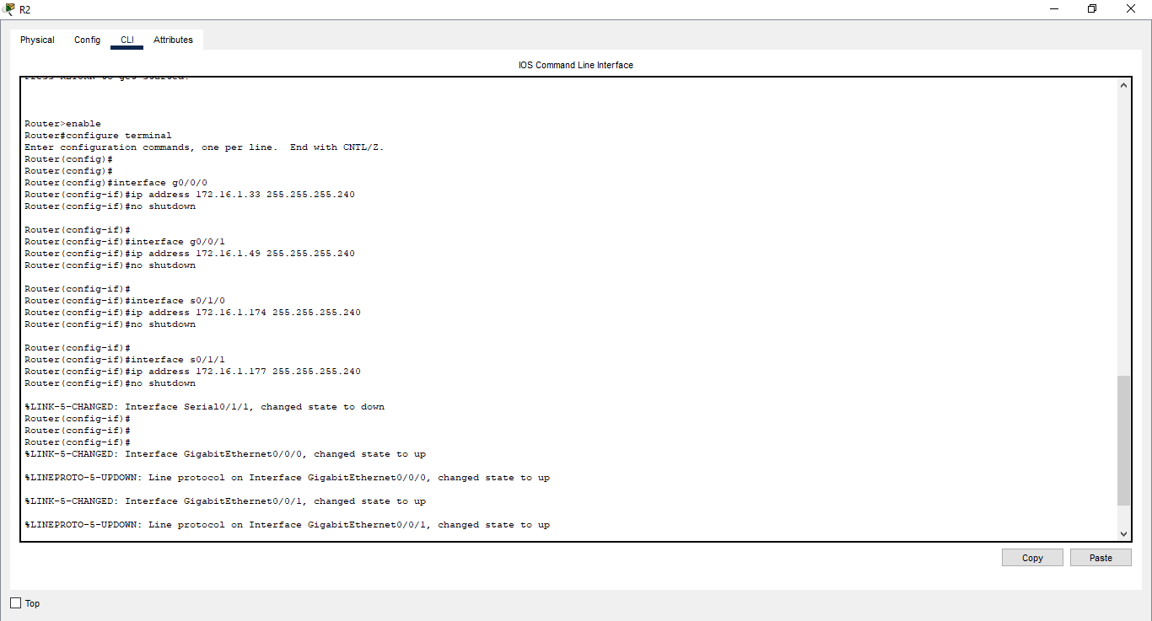
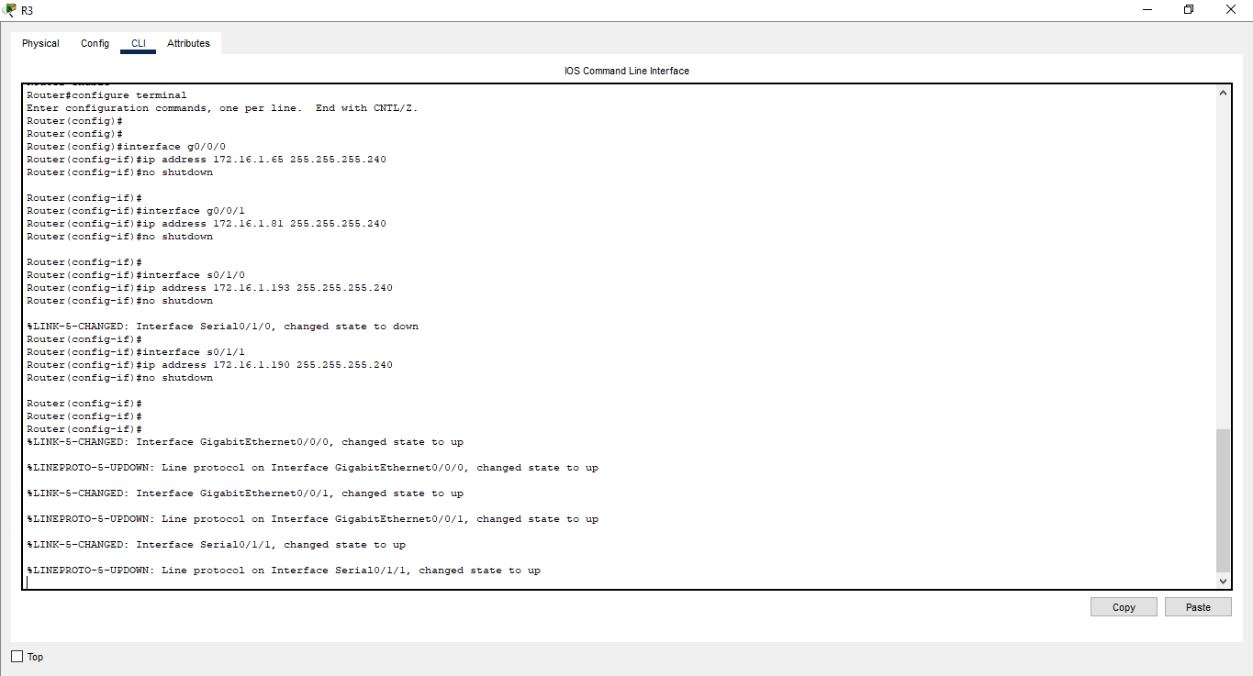

b. Assign the first usable IP addresses in each subnet for the WAN links as follows. R1 - S0/1/0 R2 - S0/1/1 R3 - S0/1/0 R4 - S0/1/1 R5 - S0/1/0

c. Assign the last usable IP addresses in each subnet for the WAN links as follows. R1 - S0/1/1 R2 - S0/1/0 R3 - S0/1/1 R4 - S0/1/0 R5 - S0/1/1

d. Assign the second usable IP address in the attached subnets to the switches.
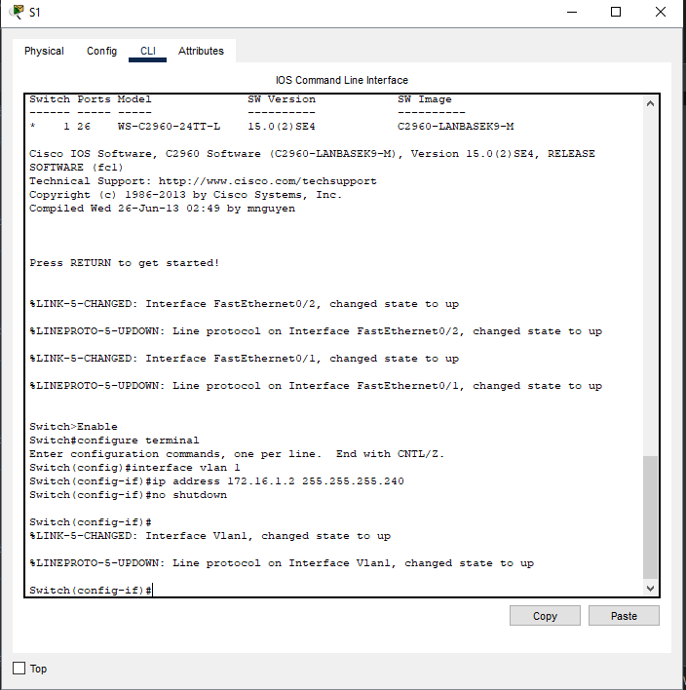

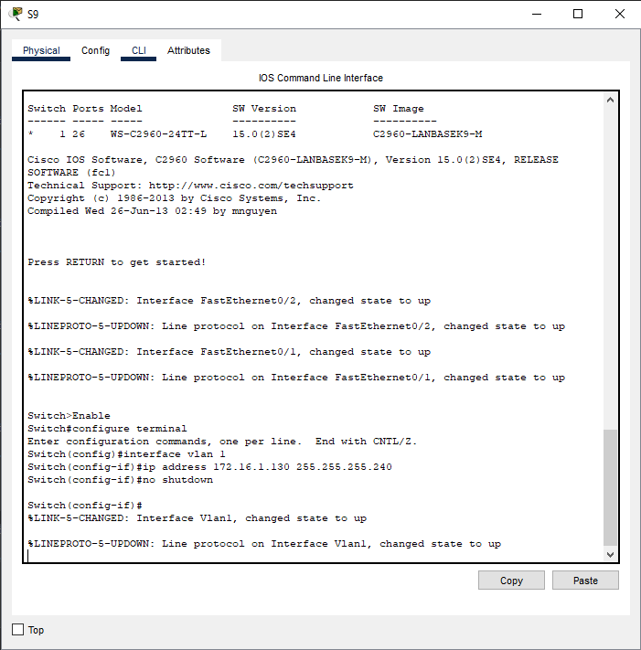

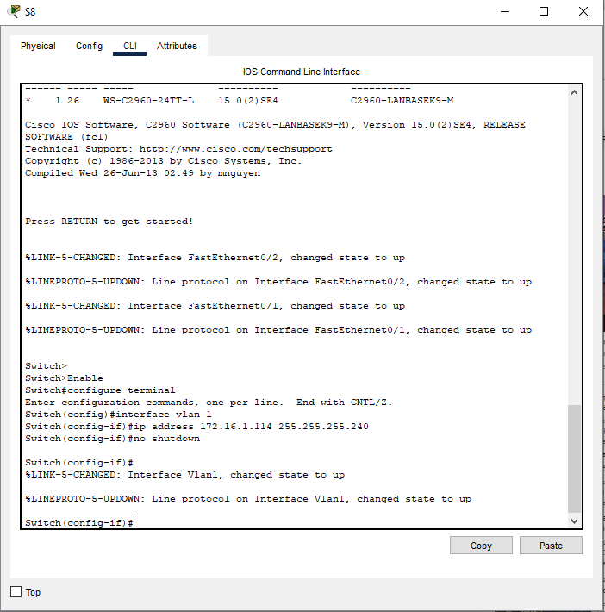
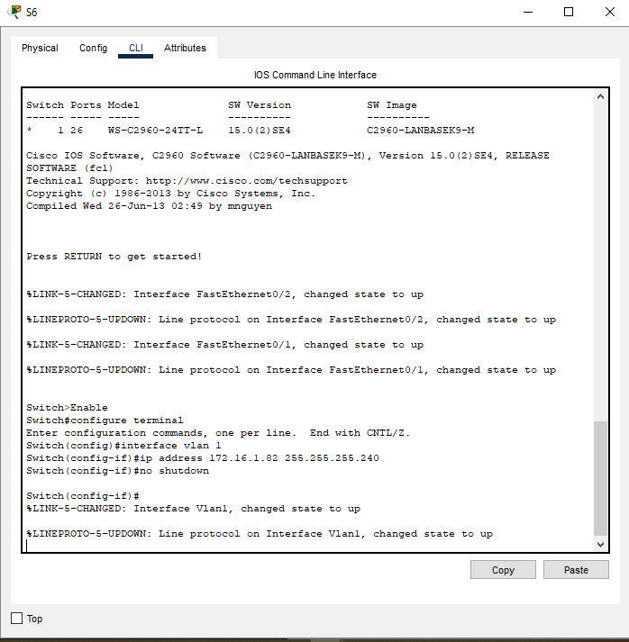

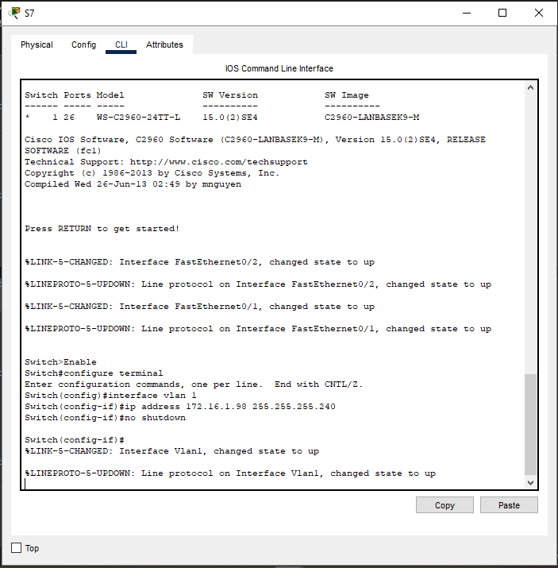

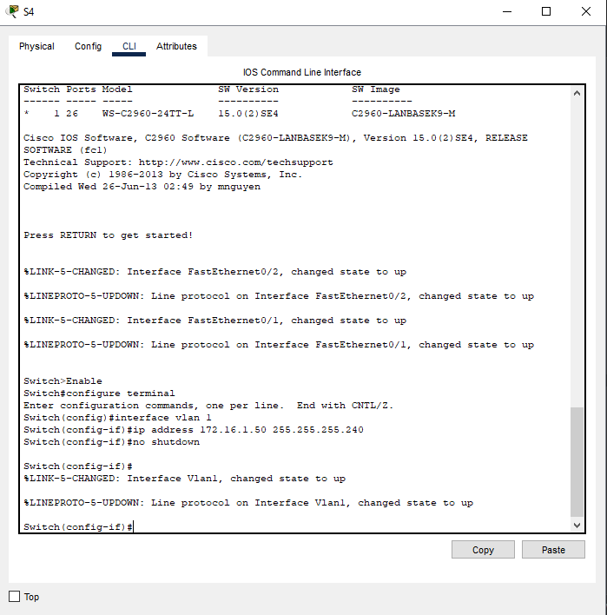

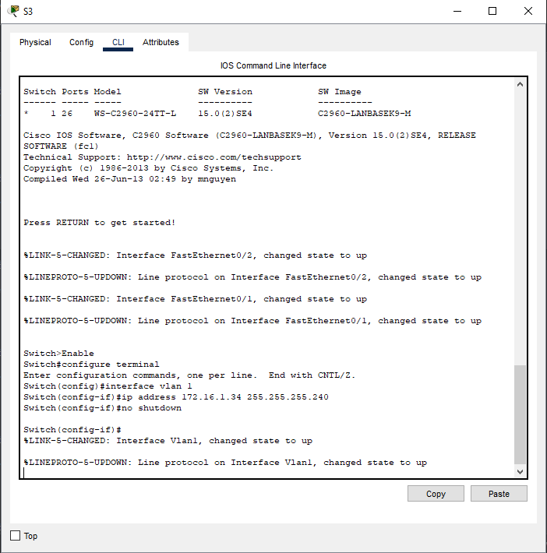

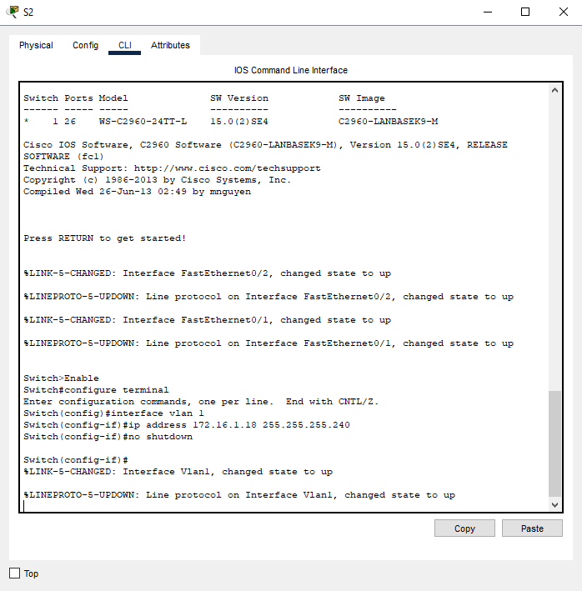

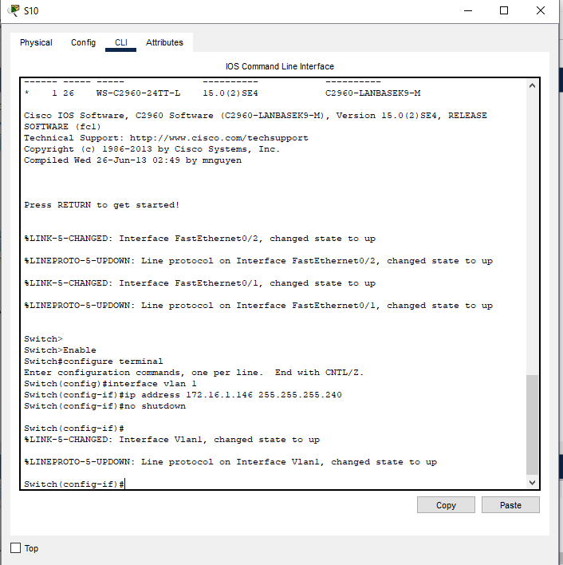

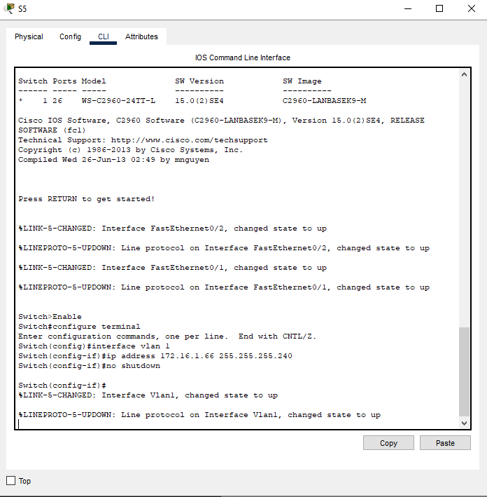

e. Assign the third usable IP address to the PCs in each subnet

Addressing Table
Devices | Interfaces | IP Addresses | Subnet Mask | Default Gateway
R1 | G0/0/0 | 172.16.1.1 | 255.255.255.240
R1 | G0/0/1 | 172.16.1.17 | 255.255.255.240
R1 | S0/1/0 | 172.16.1.161 | 255.255.255.240
R1 | S0/1/1 | 172.16.1.238 | 255.255.255.240
R2 | G0/0/0 | 172.16.1.33 | 255.255.255.240
R2 | G0/0/1 | 172.16.1.49 | 255.255.255.240
R2 | S0/1/0 | 172.16.1.174 | 255.255.255.240
R2 | S0/1/1 | 172.16.1.177 | 255.255.255.240
R3 | G0/0/0 | 172.16.1.65 | 255.255.255.240
R3 | G0/0/1 | 172.16.1.81 | 255.255.255.240
R3 | S0/1/0 | 172.16.1.193 | 255.255.255.240
R3 | S0/1/1 | 172.16.1.190 | 255.255.255.240
R4 | G0/0/0 | 172.16.1.97 | 255.255.255.240
R4 | G0/0/1 | 172.16.1.113 | 255.255.255.240
R4 | S0/1/0 | 172.16.1.206 | 255.255.255.240
R4 | S0/1/1 | 172.16.1.209 | 255.255.255.240
R5 | G0/0/0 | 172.16.1.129 | 255.255.255.240
R5 | G0/0/1 | 172.16.1.145 | 255.255.255.240
R5 | S0/1/0 | 172.16.1.255 | 255.255.255.240
R5 | S0/1/1 | 172.16.1.222 | 255.255.255.240
S1 | VLAN1 | 172.16.1.2 | 255.255.255.240
S2 | VLAN1 | 172.16.1.18 | 255.255.255.240
S3 | VLAN1 | 172.16.1.34 | 255.255.255.240
S4 | VLAN1 | 172.16.1.50 | 255.255.255.240
S5 | VLAN1 | 172.16.1.66 | 255.255.255.240
S6 | VLAN1 | 172.16.1.82 | 255.255.255.240
S7 | VLA | 172.16.1.98 | 255.255.255.240
S8 | VLAN1 | 172.16.1.114 | 255.255.255.240
S9 | VLAN1 | 172.16.1.130 | 255.255.255.240
S10 | VLAN1 | 172.16.1.146 | 255.255.255.240
PC-1 | NIC | 172.16.1.2 | 255.255.255.240 | 172.16.1.1
PC-2 | NIC | 172.16.1.19 | 255.255.255.240 | 172.16.1.17
PC-3 | NIC | 172.16.1.35 | 255.255.255.240 | 172.16.1.33
PC-4 | NIC | 172.16.1.51 | 255.255.255.240 | 172.16.1.49
PC-5 | NIC | 172.16.1.66 | 255.255.255.240 | 172.16.1.65
PC-6 | NIC | 172.16.1.83 | 255.255.255.240 | 172.16.1.81
PC-7 | NIC | 172.16.1.89 | 255.255.255.240 | 172.16.1.87
PC-8 | NIC | 172.16.1.115 | 255.255.255.240 | 172.16.1.113
PC-9 | NIC | 172.16.1.131 | 255.255.255.240 | 172.16.1.129
PC-10 | NIC | 172.16.1.147 | 255.255.255.240 | 172.16.1.145
- Assign IP addresses to network devices and verify connectivity.
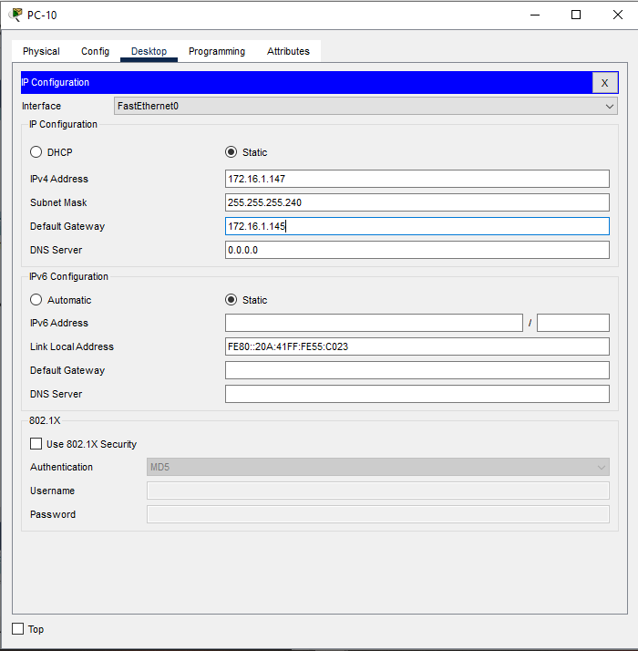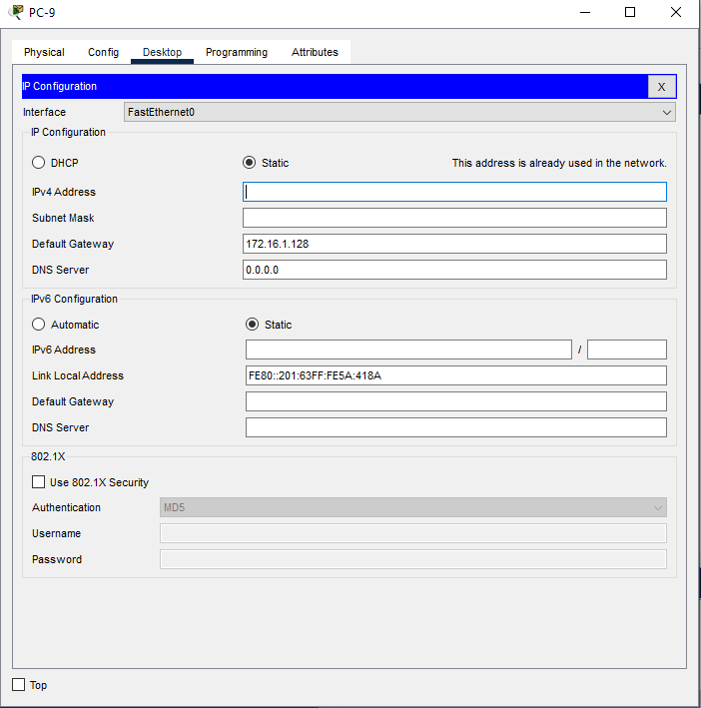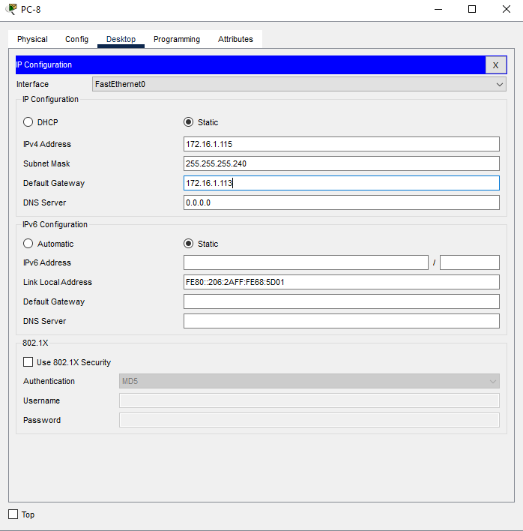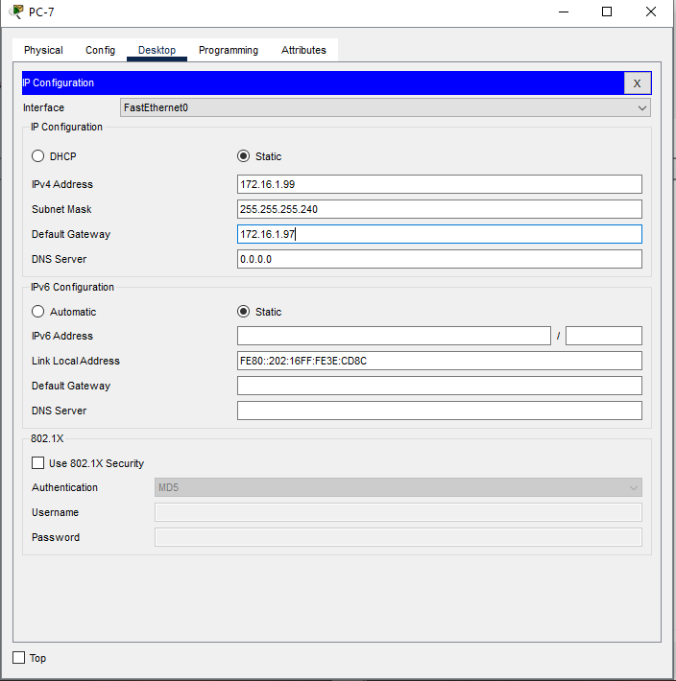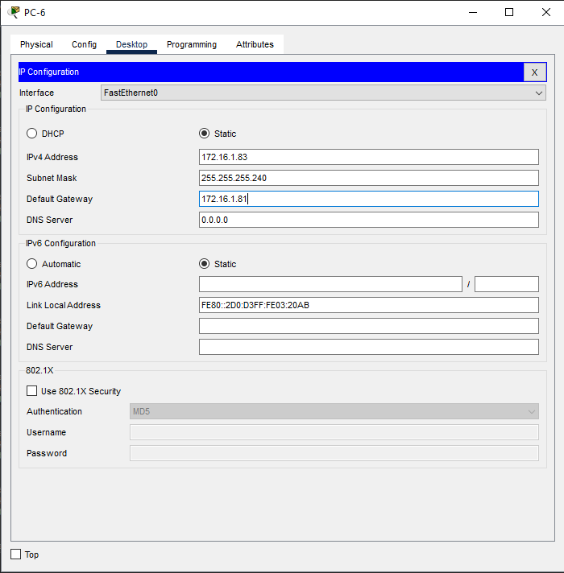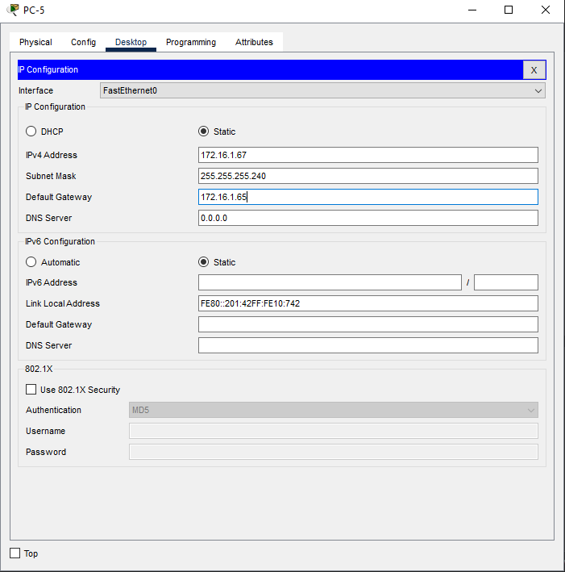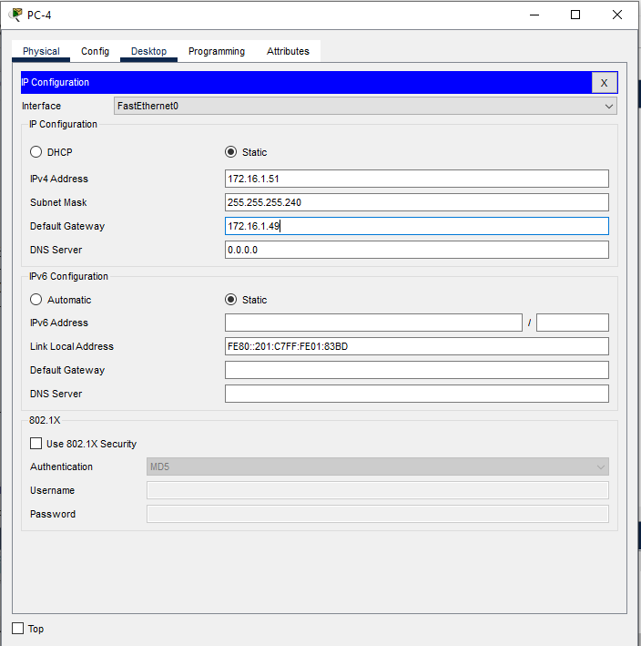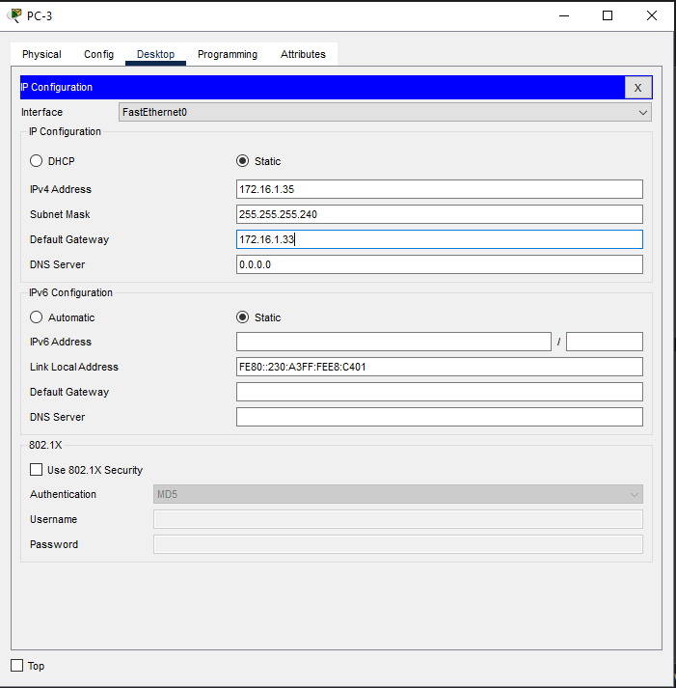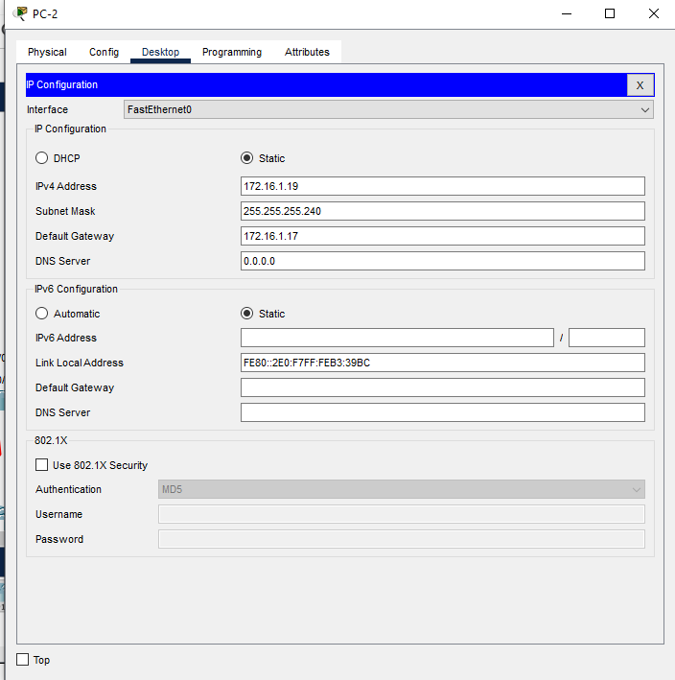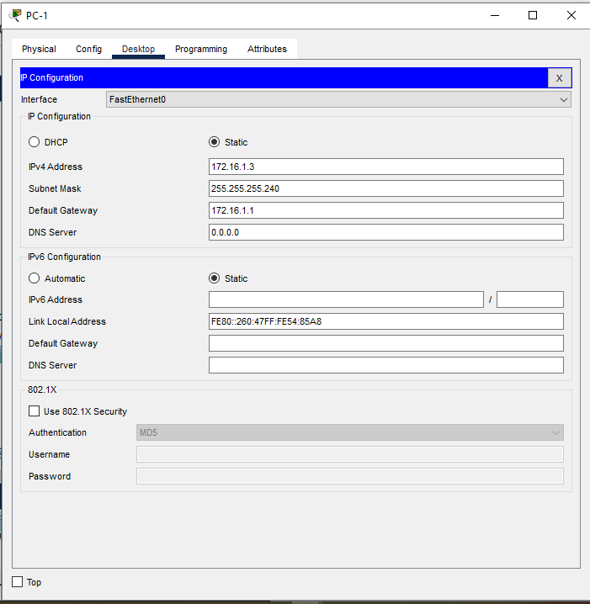

Discussion
- In this lab session, we focused on learning and implementing IPv4 subnetting and IP addressing schemes. The primary goal was to design an effective IP scheme for a network. First, we identified the main network address and, based on the requirements for the number of subnets and hosts, proceeded to divide the network using IPv4 subnetting. After creating the subnets, we assigned appropriate IP addresses to each network device, including routers, switches, and PCs. Finally, we verified the connectivity between the devices, ensuring that communication was successful both within the same subnet and across different subnets. This exercise emphasized the importance of proper subnetting for efficient IP management and network organization.

